Headless browser testing is a method of running automated tests in a web browser without a graphical user interface (GUI). This allows tests to be executed faster and more efficiently because the browser doesn't need to render the UI. Headless browser testing is especially useful in continuous integration and continuous deployment (CI/CD) pipelines where quick feedback on code changes is essential.

**Benefits of Headless Browser Testing**

Speed: Without rendering the UI, headless browsers can execute tests more quickly.

Resource Efficiency: Consumes fewer system resources compared to full browsers.

CI/CD Integration: Ideal for integrating into CI/CD pipelines to run tests automatically on code commits.

Automation: Simplifies running tests on remote servers or in Docker containers where a GUI is not available.

**Popular Headless Browsers**

Headless Chrome: A mode of Google Chrome that can be run without a GUI.

Headless Firefox: A mode of Mozilla Firefox that operates without a GUI.

HtmlUnit: A Java-based headless browser used for testing web applications.

PhantomJS: A discontinued headless WebKit scriptable with JavaScript. (Not recommended for new projects due to lack of maintenance.)

**Setting Up Headless Browser Testing with Selenium and Java**

Here’s how you can set up and run headless browser tests using Selenium with Chrome and Firefox in Java.

Dependencies

Make sure you have the following dependencies in your pom.xml if you're using Maven:

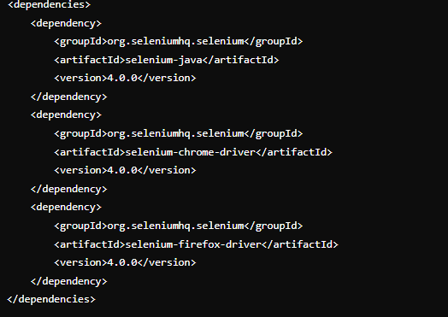

**Example: Headless Chrome**

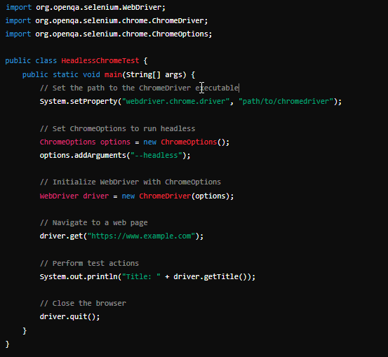

#### Example: Headless Firefox

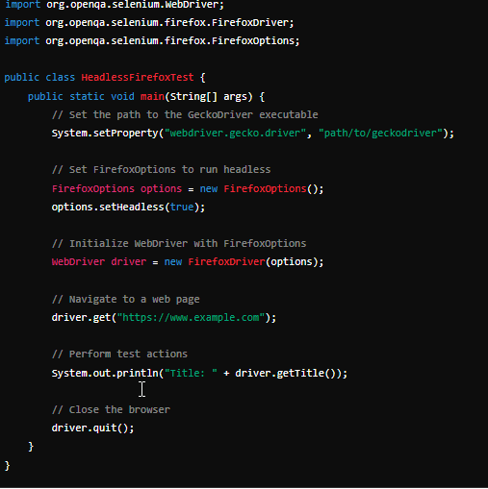

Headless browser testing is an efficient way to run automated tests without the overhead of rendering a user interface. By using headless browsers like Chrome and Firefox, you can integrate fast and reliable tests into your CI/CD pipelines, improving your development workflow and ensuring higher code quality.

Testing using different types of drivers in Selenium helps to cover various aspects of web application testing, such as speed, headless execution, and compatibility with different browsers. Below are examples of using HTMLUnitDriver, PhantomJS, and ChromeDriver (with Flash enabled) in Selenium with Java.

**1. HTMLUnitDriver**

HTMLUnitDriver is a headless browser driver that uses the HtmlUnit library for Java. It is lightweight and fast but may not support JavaScript fully as modern browsers do.

**Dependencies**

Ensure you have the htmlunit-driver dependency in your pom.xml if you're using Maven:

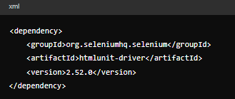

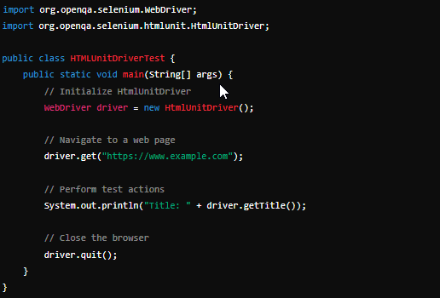

**2. PhantomJS (Discontinued, but still included for historical context)**

PhantomJS is a headless WebKit browser scriptable with JavaScript. Note that PhantomJS has been discontinued and is no longer recommended for new projects. However, here’s how it would be used if needed.

**Dependencies**

Ensure you have the phantomjsdriver dependency in your pom.xml:

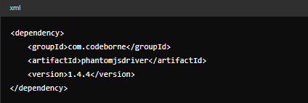

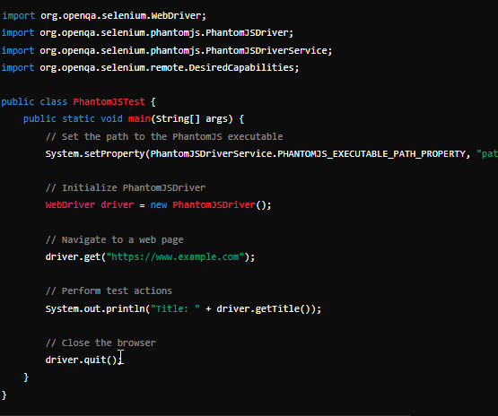

**3. ChromeDriver with Flash Enabled**

To enable Flash in ChromeDriver, you need to configure Chrome options to allow Flash content. Note that Flash support has been deprecated and most modern browsers have removed it completely. This example assumes you are working in an environment where Flash is still required and supported.

**Dependencies**

Ensure you have the selenium-java and selenium-chrome-driver dependencies in your pom.xml:

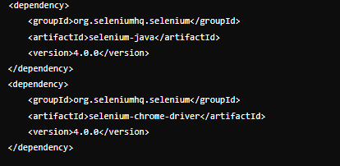

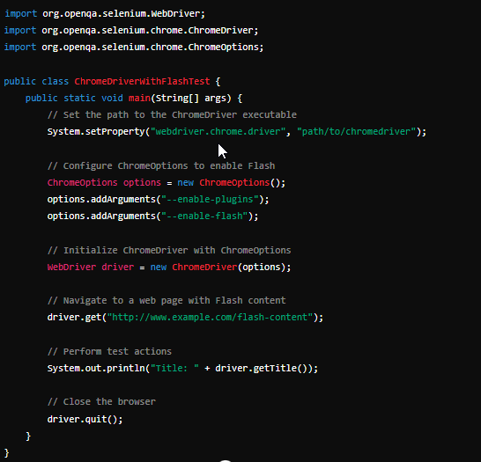

**Each of these drivers serves different purposes in Selenium automation testing:**

**HTMLUnitDriver:** Lightweight and fast for headless testing without full JavaScript support.

**PhantomJS:** Previously used for headless testing with better JavaScript support, but now deprecated.

**ChromeDriver with Flash:** For testing Flash content, though Flash is largely obsolete.